

# Weedon Station Project

Whitepaper

**Contents**

1. **Getting Network Rail’s attention.**
   1. Why Network Rail are the best people to contact.
   2. New Stations Fund.
   3. Why the DfT has not been useful.
   4. Documents I have seen.
2. **Station location.**
   1. Past locations.
   2. The location I have been looking at.
   3. Why not Blisworth.
   4. Canal and River Trust relations.
   5. Car park.
   6. Implementing a passing loop.
3. **Northamptonshire County Council.**
   1. Why we need them.
   2. What they have published.
   3. The “New Council”.
4. **Timetabling and rolling stock.**
   1. Where to.
   2. Service frequency.
   3. Rolling stock.
5. **The difficulties.**
   1. Congesting the WCML.
   2. Space for a station.
   3. Getting approval.
6. **The positives.**
   1. Connecting Weedon.
   2. Improving the economy.
   3. Getting Northants off its feet.
   4. When a station is built, people use it.
   5. Carbon emissions.
7. **Network Rail’s questions.**
   1. The questions.
   2. The answers.
8. **The research.**
   1. My survey.
   2. Kings Sutton vs Weedon.
   3. Kenilworth station.
9. **Getting in touch**



# Getting Network Rail’s attention

1.1.**Why Network Rail are the best people to contact.**

Network Rail are the best people to contact compared to organisations such as Department for Transport, ORR, and the local train operating company, London Northwestern Railway, for a few reasons. A major reason is the organisation's power. DfT and ORR manage the regulation of rail mainly, such as franchises and the law. However, Network Rail, mainly in partnership with DfT, can support campaigns like this. It makes contacting Network Rail one of the best things we could do.

We have contacted Network Rail a few times, with two prospects for a meeting at their head office a possibility. Network Rail also give out the major funding, by means of Ideas Fund and more importantly, New Stations Fund.

1.2. **New Stations Fund.**

The New Stations Fund is a government and Network Rail initiative which aims to open new stations to connect closed off communities. This does require the county and district council to help us apply, and possibly with funding to help us apply for, well, the funding. However, apart from this, we tick all the boxes. Our ‘local’ station, Long Buckby, has limited bus routes, and is supposed to serve Daventry, but LBK is nowhere near Daventry compared to Northampton station serving Northampton. Weedon and surrounding areas have not got the best bus routes to Daventry *or* Long Buckby where our so-called ‘local’ station is. It makes a lot of sense for Northamptonshire County Council to apply for funding and support from the New Stations Fund programme.

Of course, we could also classify this station as a Parkway station, acting for Daventry. If the station project is approved, it is more than likely the station will become “Daventry Parkway” In this document, if “Daventry Parkway” is mentioned, it means Weedon Station in this instance.

**Update (07/07/2020):** The New Stations Fund applications closed a few days ago. However, I got a response from Grant Shapps’s office saying that I need to get an MP to sponsor the project, although the applications were already closed at that time. I do not really understand that, but I know that Chris Heaton-Harris is also on the Idea’s Fund board, so I do not know how that would work.

1.3. **Why the DfT has not been useful.**

I am not saying that the Department for Transport has not been *entirely* useless, but they could have helped a little more. After doing some searching for why they do not care as much as Network Rail, and why they are referring me to them, it seems like Network Rail just manage this type of thing, and the government department just manage the regulation of the travel industry and approve things. So, if we ask Network Rail for funding or support, it is likely they will go to a representative at the Department for Transport to talk to them about it, not us directly.

When we did get in touch with Department for Transport, they referred us to their funds, which are in partnership with Network Rail, and Network Rail themselves. This also hints more to that we should be contacting Network Rail instead of the DfT organisation.

1.4. **Documents I have seen.**

As of the 26th of June 2020, I have only received two documents from my FOI request to the Department for Transport, one of them being useful, and the other not so much. The useful one is titled ‘Investment in stations 2017’ which details how Network Rail invests in existing or new stations, the guidelines for requesting funding and other useful info.

The other document is directly written by the Department for Transport and it is titled ‘Rail Network Enhancements Pipeline’. I did not read much of this document, but on the surface, it does not seem to help us, but could help the county council.



# Station Location

2.1. & 2.2. **Previous location & the location I have been looking at.**

After doing a lot of research, I have found the exact location of the station, and the location of Marton Junction, which was a line connecting Weedon and surrounding villages to Leamington Spa via Daventry. This line is now closed. Below is an image containing the location of the previous railway station, with helpful annotations of what a station could look like today.

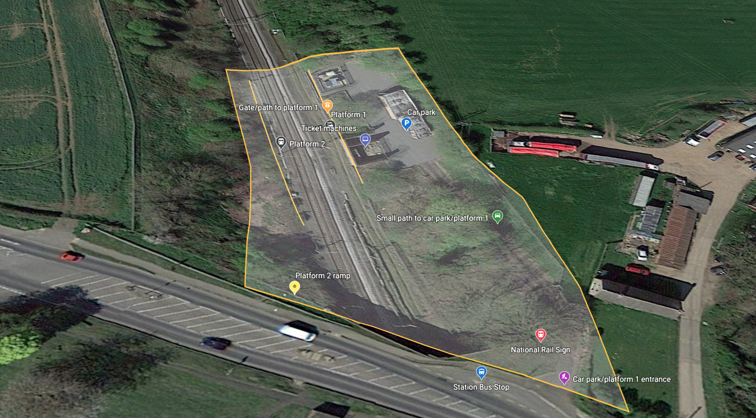

The map that I have annotated above does not have any accessible entrances or exits as you can see. The stairs to the bridge which is the exit/entrance could also have a ramp. We would follow government standards while planning and building this.

Adding to the positives of Weedon station compared to LBK is that Long Buckby does not have much all-accessibility. No ramps are at Long Buckby, so there is no way for wheelchairs to get to platform level. Weedon station could supply this demand by adding accessibility features that were not thought of in the building of Long Buckby all those years ago.

The location opposite is now home to ‘The Boatyard Weedon’ which consists of ‘Concorform Marina’ and ‘Bosuns Locker Self Storage’. This location is situated on High St in Weedon, near the Heart of England pub and Tesco Express. I have not contacted Network Rail about this yet, but I can see this location is possibly used for access to the railway by Network Rail Staff.

To add to the reliability of this location, recently, Strutt and Parker have purchased land opposite this proposed location to build 47 new homes! This would bring amazing traffic to not only the station, but Weedon as the new homeowners would be interested in the transport links. This could not have been any better timing, what a great time to build a station. These are not the only developments, there are others going on in surrounding areas. A map is below:

**UPDATE:** I have just been to this location and it seems like a really good location including a bus stop, good transport links to local areas, space for platforms and more benefits of it being built there. This map published by Strutt and Parker, the developers of the new housing estate, shows where they plan to build:

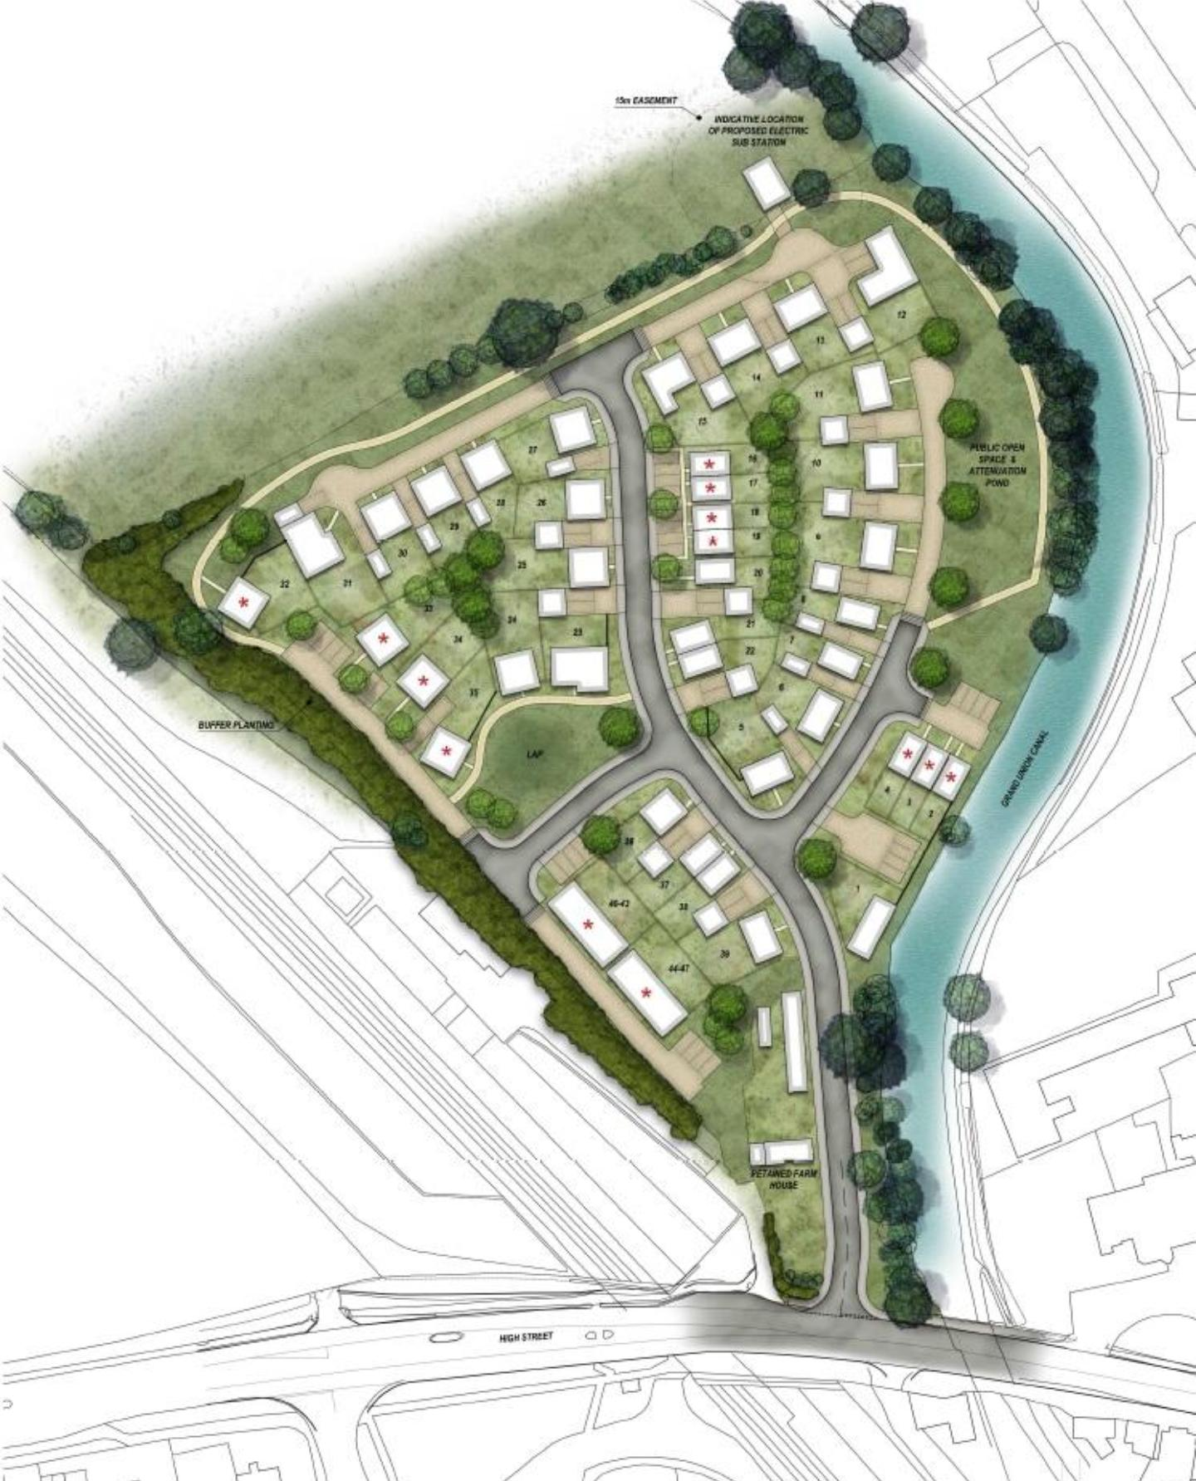

2.3. **Why not Blisworth.**

After doing some research of maybe building the station in the village of Blisworth, it seemed to me that Blisworth may not need a station as much as us. They have almost the same population, but most of the people who live there, also work there. Because of this, I am focussing on Weedon Bec more than Blisworth for this specific project.

**Update:** There are two other main reasons I oppose a station in Blisworth instead of Weedon:

1. The residents of Weedon have shown so much enthusiasm, they really would like this station.
2. Daventry is closer to Weedon, and Weedon has a lot better road links with Daventry.

2.4. **Canal and River Trust.**

I was recently told by a friend that the Canal and River Trust CEO has a connection to rail. I decided to do some research on him, Richard Parry. I was not expecting him to be the former director of FirstGroup which operates the most major railway routes in the UK including Avanti West Coast, Great Western Railway and South Western Railway. Having this connection to the railways might mean he could decide to help us as this could also help his charity to find more people who are interested in the canals, and to give them a better transport link.

2.5. **Car parks.**

At the old station, there is currently no car parking space near the station (except on the map I inserted earlier, however, this could be used as the passing loop, more on that later), but other car parks are available such as the Network Rail owned land near Concorform Marina on the other side of the road, or a car park used for the housing estate opposite. There is a small lane leading to the buildings next to the old station platforms. This may be worth looking at, as this could be the new car park/ticket machine locations or even an entrance to one of the platforms, and this location would be accessible.

We will be following government guidelines when it comes to car parking, and we will include accessible parking spots, and EV chargers will be implemented. Below is the map of the proposed car park close to the station, which may be used by the passing loop:

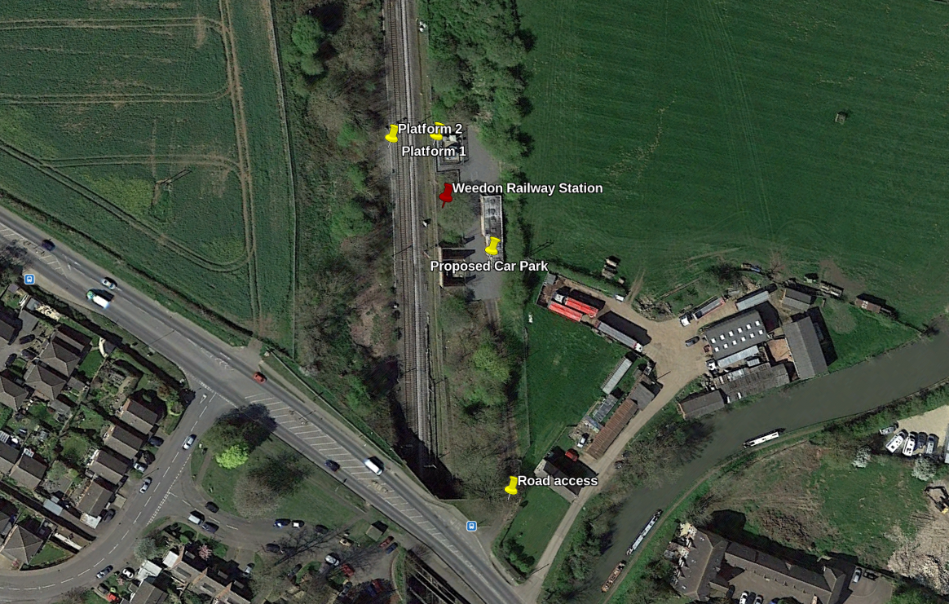

However, I am not sure who this land is owned by. I have contacted HM Land Registry for more info.

As well as this, cycle hire schemes such as Santander Bikes, which are now owned by TfL, have been booming around the UK including in Northampton and Milton Keynes. If these bikes become countywide, there could be a need for a new dock for these rented bikes at the location, as well as standard bicycle racks. This would also be an eco-efficient way of getting to Weedon Station. Also, car park spaces in this proposed car park location where the passing loop may be will need to be looked at, as the government has guidelines for sizes of car park spaces for standard cars and people that require more space to get out of the car. When checking this space out, we will need to see if this space complies, especially for a parkway station, whose purpose is as a park and ride service.

2.6. **Implementing a passing loop.**

Another idea I had was to make a split in the rail, so the non-stopping high-speed Avanti West Coast services could continue the West Coast Main Line, but the stopping London Northwestern Railway services could go onto a different line. This is likely to cost more but would mean congestion on the WMCL would no longer be a problem. I am thinking about this.

However, if this passing loop were integrated into the design, we would have to bear in mind more than likely having to relocate the proposed car park I was talking about earlier, as the passing loop would fit right in to where the car park would be (as seen on our example map design). We could make an agreement with the neighbouring pub (a Marston’s), to “rent” parking spaces out to London Northwestern Railway, however, the likeliness of having enough space for a parkway station is unlikely. Or use the area on the opposite side of the road at “Concorform”.

As well as this, if a passing loop were integrated, an island platform would be used instead, so another set of stairs would not have to be added, and both platforms would be on this island, with one set of stairs leading down to it. Platforms would only exist on the passing loop/fast lines, depending on if the fast services will go via the passing loop or the fast line and vice-versa. No platforms will exist on the route the fast services decide to pick.



# Northamptonshire County Council

3.1. **Why we need them.**

Northamptonshire County Council play a vital role in this project. They are our connection to the Government and Department for Transport. They approve what we have suggested to them and they help us fill out the application forms to communicate with Network Rail (which are, as I had said, the most important organisation in all of this). They even help us request funding. Without the County Council’s support, this whole project is for nothing, and will never get anywhere. The only communication I have had so far with the NCC is an FOI request.

3.2. **Documents they have published.**

The Northamptonshire County Council published the last Northamptonshire Rail Strategy in 2013. If this document were updated, it could give us a better look into what the county is doing in terms of rail. However, I am going to use this document anyway to explain a bit about what their thoughts were 7 years ago.

They were thinking about many improvements to existing stations, according to their document. Including:

* **Corby:** Second platform
* **Kettering:** Improved station access
* **Kings Sutton:** Lengthening of platforms
* **Long Buckby:** Permanent station building
* **Northampton:** Comprehensive redevelopment
* **Wellingborough:** Restoration of 4th platform

Which of these things have been completed, you may be asking?

* **Corby’s second platform:** No, not completed.
* **Kettering’s improved access:** Nope, but they have lengthened the platforms.
* **Kings Sutton’s platform lengthening:** Not yet, but the residents still want it, it seems.
* **Long Buckby’s station building:** Nope, just a ticket office.
* **Northampton’s redevelopment:** Yes! They rebuilt the entire station from the ground up.
* **Wellingborough’s 4th platform:** Yes, very recently by Network Rail.

**But the info that I had interest in the most was the following:**

‘We will examine in more details proposals for stations at the following locations

* A new station at Blisworth or Weedon on the West Coast Main Line
* Station sites south of Northampton on the Northampton Loop
* New stations at Desborough and Irchester on the Midland Mainline.

This was great to hear, then I remembered that was 7 years ago and none of that has been completed. I created an FOI request to the DfT to get a follow-up on this document with the following reply:

‘The Department for Transport (DfT) has not undertaken any development work on proposals for a station in either of these locations.’

At least this document reassured us that if we do make a proposal for a station at Weedon to serve us and the surrounding villages, and of course, Daventry, it is likely for the county council to approve funding and make it happen.

3.3. **The “New Council”.**

Northamptonshire County Council has not got much money (ahem, no money), so a few years ago, the Secretary of State for Local Government sent a handful of people to Northamptonshire to investigate what is going wrong in their community. These agents came back to Department for Local Government and informed them of what changes they suggest. One of them was to implement 3 new councils, Northampton Borough Council, North Northamptonshire Council and West Northamptonshire Council. Another was to implement one massive council, Northamptonshire Council. However, the choice made was 2 new councils, North, and West Northamptonshire Councils.

These new councils will be “Unitary Council’s”. A structure used by most UK counties these days. This means that all Local Government services will come over one council, both County and District council services.

This new council will have a relatively large impact on our plans, meaning new contacts will have to be found, and a new policy will be implemented for many things which the local Government is responsible for, one of them being of course Transport Planning.



# Timetabling and rolling stock

4.1. **Where to.**

As this station is most likely going to be served by London Northwestern Railway, we have a lot of options on where customers could travel to from this new station, including London, Birmingham and as far north as Liverpool! Long Buckby receives services to Northampton, Rugby, Birmingham New Street and London Euston with services multiple times a day. To find out more data about what the residents think of this, please refer to section 8, paragraph 8.2.

After I did some more research, it turns out it takes about 80 minutes to get to Euston from Long Buckby although Weedon would be about half at 40 minutes. This is another benefit of being on the ‘fast lines’ on the WCML.

4.2. **Service frequency.**

I have been doing a lot of research on service frequency, and these are the numbers of services daily at Kings Sutton and Long Buckby. Please note that Kings Sutton is managed by Chiltern Railways and Long Buckby is operated by London Northwestern Railway so their business strategy may vary.

|  |  |  |  |
| --- | --- | --- | --- |
| **Station name** | **Services (weekdays)** | **Services (Saturdays)** | **Services (Sundays)** |
| Kings Sutton | 12 | 10 | None |
| Long Buckby | 58 | 51 | 41 |

With this data, we can see that rural stations such as Long Buckby, which is a similar village to Weedon need a service that is often as if they did not LNWR would not operate them, or the DfT would cancel them. If this is the case in Long Buckby, then it will be a similar case here. Taking this data into account, here is what I have come up with. Please note that these numbers are if LNWR operated *only*. These are not final numbers either.

|  |  |  |  |
| --- | --- | --- | --- |
| **Station name** | **Weekdays** | **Saturdays** | **Sundays** |
| Weedon | 35 | 27 | 21 |

If these numbers were to be put into effect, they could be changed in the future if higher demand is met.

4.3. **Rolling stock.**

London Northwestern Railway benefits from having a lot of rolling stock (EMUs mainly), and that they are operated by West Midlands Railway which has even more. Class 350 EMUs are currently used at Long Buckby and most of the way across the London Northwestern Railway network, so I assume that this will be the same at Weedon. West Midlands Railway currently leases 87 Class 350 EMUs for use on the LNWR network. I do not see the need for more rolling stock as Weedon will just require the same rolling stock stopping there, not brand-new lines or routes.

One thing that many people are worried about is the environmental consequences of using rail. To those people, I reassure them that the rolling stock that will be stopping at the station will be fully electric, as it will be the London Northwestern Railway Class 350 EMUs planned for use, which are Electric Multiple Units. They are green and good for the environment.



# The difficulties

5.1. **Congesting the WCML.**

One of the main difficulties we will have to overcome is building a station in the middle of the WCML. This would mean Intercity and busy Avanti West Coast services which run on the same route either must slow down to allow LNWR services to stop at the station, or another solution such as a passing loop for the Weedon services to pull into to continue allowing the Avanti West Coast and other LNWR services to pass. The only problem with building a passing loop would be the space for that.

However, the North is dotted with stations and the North is one of the busiest areas on the West Coast Main Line. If the North can do it, we can do it too. Especially if we are quieter than the North. This is the same in the South East as well.

HS2 could also help us with taking stress and congestion off the West Coast Main Line, which will allow us to build this station as it would not bother the Intercity Avanti West Coast services as much. If we start constructing a station now, before HS2 is built, and run a limited LNWR service to it, it will not congest the West Coast Main Line as much and when HS2 is built, we can run a standard service to the station because stress will be taken off the WCML.

HS2 does not serve any Northamptonshire location. This is the government's time to make the Northamptonshire people care about rail, and this is also the government's time to ‘say sorry’ by building us a station, instead of serving us by HS2. The Government has said that HS2 will take stress off the WCML, and that is the main reason they are doing this massive project in the first place. If there is less stress on our line, then you have no reason not to build a station here. If you can build a station in Milton Keynes or Rugby, then you can in Weedon, serving an ever-growing town of more than 25,000 people (Daventry).

# 

5.2. **Space for a station.**

Weedon is becoming quite a dense place, but I do have a perfect place in mind. This means that if this location does not work, there might not be anywhere for the station inside the actual village which would mean locating it on the outskirts of the area, and maybe not even putting it anywhere near Weedon which would mean residents could not access it as easily, but this would mean other villages could access it as well. The idea for the location which I have proposed I have quite a lot of hope in, so I do not expect this to be a huge problem.

5.3. **Getting approval.**

This is the least of my worries, but I thought I would mention it anyway as it could become a problem in some circumstances. In section 3.2 of this document, I said that Northamptonshire County Council said that they would support a proposal for a station in Weedon, so I expect the county council would 100% support this project, but it is Network Rail’s final decision if we were to hook into the New Stations Fund. If we are denied for investment from Network Rail, this could be a problem.

**Update:** On second thought, it is likely the current two-tier Northamptonshire County Council will decline funding for us, due to their financial position, and their ban on new spending. In this case, the new West Northamptonshire Council will instead fund the project. The new unitary is due to come into power, and dissolve the two-tier system, in early April 2021.



# The positives

6.1. **Connecting Weedon.**

And not just Weedon, also the surrounding villages, and of course, Daventry.

For a while now, Weedon has not had the best transport links, with weak bus connections to nearby towns, and taxis being non-existent. Rail will certainly fill this gap, especially with reaching further to reach places such as London or Birmingham. As well as this, it will also connect Weedon to Northampton, Leamington Spa and even Long Buckby as well. In the future if more stations are built, the station could also link residents to there, so it is kind of future-proof.

As well as this, in a relatively new housing estate in the North of Weedon, Cavalry Fields, has had 80 new houses sold since 1995, and that is only one estate. 4 new housing estates have opened in 5 years in the Weedon area. All these people will require transport links to the nearby community and beyond.

Another great point is the A45 link road which was built quite recently. This supplies an easy route from Flore and surrounding areas to access the new Weedon station.

Of course, the main reason for this new station is to serve Daventry (hence the name “Daventry Parkway”). This proposed station would be a lot easier to access than Long Buckby, due to a main road already existing (instead of Long Buckby station's country path). This main road goes right to the heart of Daventry too. No “changing roads”, just one direct journey.

6.2. **Improving the economy.**

Not just in Weedon, but in the entire county. Allowing people who have not got a station to have access to one means that they will travel on rail more. This will not only bring in more revenue for the Train Operating Company, but also the council and Network Rail as Track Access Charges must be paid. In the long term, this could really improve not only the county's economy, but also on a national scale. In the future, this could ‘ping’ Northamptonshire County Council to build more stations if they see these things happen, which would then improve the county’s economy again, then the country’s and this will continue going on and on, and then Northamptonshire will be back on the rail game.

Another way this project can benefit the economy is attracting more commuters to move to Weedon, the surrounding villages, and Daventry. This links well back to the new housing estate in Weedon, attracting commuters to buy or rent one of these houses for easy access to the station, within a short walking distance.

Boris Johnson himself said on the 30th June 2020, the following: ‘...and connectivity between the regions of the UK, to unite and level up, and to that we will Build Build Build.’ I think Boris Johnson is forgetting about Northamptonshire, which is not very connected via rail. You can connect us by building building building a station in Weedon! You can also ‘build back greener’, as rail might be the most economical way of connecting the regions of the UK.

Section 106 will also benefit the local community and maybe even help fund the train station, with the new development being built next to the station. This housing estate company needs to invest in the local community, and they may do this by investing in a new station. This will also benefit their new renters too, as a station will be relatively close to their estate.

6.3. **Getting Northants off its feet.**

As I explained in the last paragraph and further up in this document, Northamptonshire has been terrible at its ‘rail game’ in recent years, and even decades. If Northamptonshire’s County Council (and “new council”) sees the improvements in their economy and in general, they will continue to build new stations to attempt to improve this effect. This would mean Northamptonshire would no longer be known for having terrible rail links.

6.4. **When a new station is built, people use it.**

As we can see in stations such as Corby, in the last 10 years, it has reached half of what a nearly century-old station has in terms of passengers. That is amazing. This proves that when a station is built, people use it, and this is not an exception to Weedon. And this effect does not just wear off over time, I have created a chart below to show Long Buckby’s yearly passenger numbers, and you can see they increase in tens of thousands a year! Even these numbers shocked me. As you can see, these numbers are set to increase again last year (data not recorded yet), and then I expect a bit of a slope down this year due to Coronavirus, but then a huge jump up in 2021 due to this.

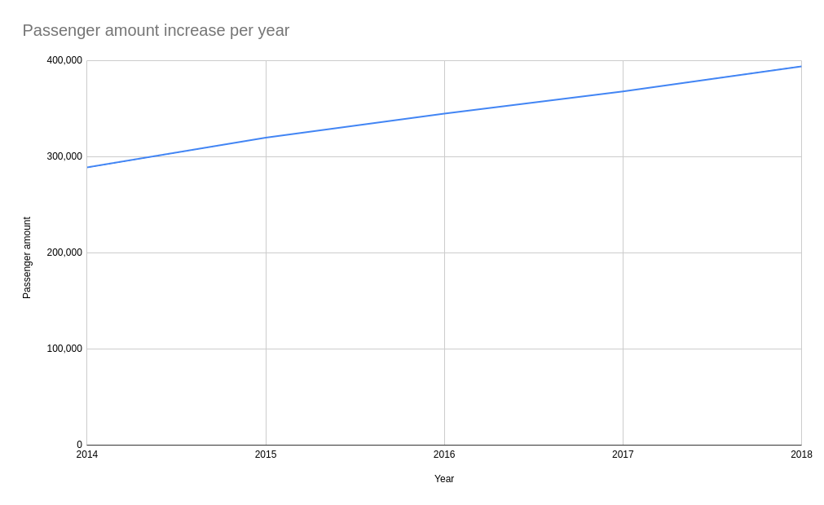

6.5. **Carbon emissions and climate change.**

According to our research, it seems most people living in and around Weedon use their own cars or buses to get around. This will cause a lot of carbon emissions to be exposed. Using electric rail instead will save diesel/petrol and save the environment at the same time, contributing to the UK’s climate change promise. As well as this, we plan to implement EV chargers at the station, allowing people to drive their electric vehicle to the station and charge while they are on the train. This will attract more people in Northamptonshire to purchase an electric vehicle, and possibly start an electric charging “boom” in the county.

I also mentioned a possible hire bike dock in the station. Recently (Dec 2020), these bikes, and more popular, scooters, have become a big part of the county, especially within Northampton and Kettering, nearby large towns. Next in line for them should be Daventry. If this station is approved, it could encourage people to undock within the town centre, and cycle to Daventry Parkway and dock back in, depart on their train, and then ride back to Daventry when they are back.



# Network Rail’s questions

7.1 and 7.2. **The questions and answers.**

All of these questions were found in Network Rail’s ‘Investment in Stations’ booklet in section 05: Planning a new station. Below in the next paragraph/section are our answers to all those questions. If I have already answered a question in a different section of this document, we will refer to that paragraph or entire section.

7.2. **The answers.**

1. **What are the benefits associated with the opening of a new station?**
   1. See section 6: The positives.
2. **What are the negative impacts that might be associated with a new station?**
   1. See section 5: The negatives.
3. **Is the new station likely to be affordable?**
   1. Yes, the rail infrastructure is already in place, and it will be easy to gain revenue to make up for the upfront cost of building platforms etc. However, recurring services such as internet and electricity may not be available in some of the proposed locations. Staff will most likely not be required because it will be a small station. This will save a lot of money. However, cleaners may be required, but I am sure members of the community such as myself would be happy to volunteer to take this role. Vandalism is rare in Weedon and the surrounding areas, including Daventry, so I would not worry about replacing certain items such as passenger information systems/screens. We honestly have a lovely community here.
4. **Has a train service operator been identified?**
   1. Yes, London Northwestern Railway will be operating the services as they already operate services on the WCML. TOC operating costs will not be affected very much, as all the TOC will have to do is stop their train at a different station. Avanti West Coast is unlikely to stop their fast services at Daventry Parkway unless passenger numbers are higher than expected.
5. **Has a Station Facility Owner been identified?**
   1. As London Northwestern Railway are the only operator which are likely going to be stopping at the station, it makes a lot of sense for LNWR to be the station facility owner. Network Rail only manages larger stations, so this makes the most sense. The costs of running the station day-to-day will be low as having a ticket office will probably not be essential for Weedon residents. Read more about this on question three.
6. **Is the new station proposal consistent with the vision for the route set out in the relevant route study?**
   1. Yes, the new station is consistent with the vision of the London North Western Route Specification. It is focussed on long distance and commuter markets, which is exactly what the station's goal is.
7. **Is the railway used exclusively by one type of service, or a mixture (e.g., stopping, express, freight etc.)?**
   1. The railway is used for all the above. Stopping trains include London Northwestern Railway services, express include Avanti West Coast services and freight mostly during the night. If you were wanting to avoid clashes with freight, running services during the night may be impossible, and normally does not happen with LNWR services anyway.
8. **In terms of destination, timing and stopping pattern, do existing services passing the site ‘fit’ with the anticipated patterns of travel from the new station?**
   1. We expect most passengers would be travelling to other destinations on the West Coast Main Line. The only destination that is not accessible directly is Northampton which is on the Northampton Loop. There is nothing we can do about that other than tell passengers to change at Rugby for Northampton.

**Other considerations**

|  |  |
| --- | --- |
| What is the proposed platform length? | 4-8 cars long, depending on the rolling stock running through the station (class 350 EMU) |
| Is the railway curved or straight at the location of the proposed station? | The railway is relatively straight at the proposed location. |
| How many new footbridges will the station require? | One only, or none depending if the other platform is accessible using the existing A-bridge. |
| Is the railway in a cutting/on an embankment /difficult to access? | The line is about to go through a tunnel, so slightly below path level, and on a slight cutting. |
| Is road access available to the site/is adequate land available for parking? | Yes, exceptionally good road links, but land may not be available for parking close to the station. |



# My survey

8.1. **My survey.**

I thought it would be valuable to go over some results I got from a survey I did from Weedon residents. These are my results.

I am going to list a few facts I have recently found out from the survey, if you are interested:

* 47.9% of residents would take the train to London most, along with 27.7% to Birmingham and 11.7% to Milton Keynes Central. I am happy to say that none of these three journeys would require changes at other stations.
* In fact, only 8.6% of people would require changes to get to their destination from Weedon, these include:
  + Manchester
  + Northampton
  + Reading
* Most residents travel with London Northwestern Railway who will manage the station and serve it with their trains. The TOC goes all the way from London to Liverpool with major stops such as Birmingham, Coventry, Crewe, Stoke-on-Trent, Stafford, Nuneaton, Rugby, Milton Keynes and more.
* Currently, most people use Long Buckby the most, with Northampton a close second and Milton Keynes Central third. All these stations excluding MKC are served by London Northwestern Railway only.
* Only 12.9% of people currently commute to work via rail, but 10.8% of people said they would convert to commuting by rail if a Weedon Station was to exist.
* 86 people have used Long Buckby station before, along with 85 people who have used Northampton. Only 12 people have used Wellingborough station, and only 1 person has used Corby station.

I would like to address some concerns that residents have:

* Noise: I can assure residents that the station would be on the outskirts, far from the main housing part of the village. The station would be on the high street under the A45, where the West Coast Main Line goes under the road. Until HS2 is built, the service will be infrequent due to the congestion of the line, unless a passing loop is built.
* More people: Some people have bought up the concern that it would not just congest the line, but congest the village, and the nearby roads. I can also assure residents that this would not be an issue as the station is designed to be built on the outskirts of the village, which is not nearby any houses. Car parks would be available at the station, so Weedoners do not need to worry about commuters stealing their parking space!
* Accessibility: One of my main goals with this station is to improve accessibility to rail for people in wheelchairs, and as someone said in the survey, pushchairs. Most stations in Northamptonshire are not accessibility friendly. Weedon is going to be different. Ramps will be available to platform level, as well as passenger information screens and sounds for people who cannot see. We will be following government standards when it comes to ramp steepness, and handrails etc. We want Weedon station to be the friendliest it can be. Accessible car parking spaces will be available.

As well as the issues, there are also people who mention how the station could change their lives, some that I want to share:

* ‘I feel the demand is there. Nearest station to Weedon is Long Buckby’
* ‘I would like to bring up my two children in such a way that they are less reliant on cars’
* ‘This would be so much better value than HS2’
* ‘I used to live in Bletchley and was able to walk to the station and spent many days in London on day trips. Since moving to Weedon we now have to consider lengthy taxi rides and for this reason we don’t do it so frequently.’
* ‘In a world that wants us to use public transport rather than the car it makes perfect sense to reintroduce the station’
* ‘...Not having a station, when a line already passes through the village, seems really odd. The village gets all of the negatives of having a train line (noise etc.), but none of the benefits…’

8.2. **Kings Sutton vs Weedon.**

A question I have been wondering this entire time is Kings Sutton compared to Weedon. Why does a village of 2,000 have a station, although a village of 3,000 (Weedon) and the surrounding villages don’t although we have a railway speeding through? I tried to find info, but I just could not see why this is the case, because it just *makes sense* to build a station in Weedon. Since Kings Sutton was built in the mid 1800’, it has gone through so many events, so many franchise changes, so many renovations, but Weedon station was just closed? It does not really make any sense. I have been told it may be worth getting in touch with the council to do more research on this.

8.3. **Kenilworth Station.**

Kenilworth station is one of the newest stations in the UK. Because of this, I wanted to do some research into the time scale of this station, how it received funding and who was involved. I have created a short case study below on the info I found.

In 2013, the county council (Warwickshire), announced that the station would be reopened, and work starts soon. After this, the time scale became a bit confusing to me. All I know after this is that it took one year to build, and it took 2-3 months to build ‘the parts you actually see’ such as the station building, platforms, and footbridges. Yes, this station did have a footbridge and station building which I doubt Weedon will have so it may even take less time! The station opened in April 2018, after a delayed launch because of weather in December of 2017.

Due to the station having a footbridge and station building, this time would be longer than an estimated build time of Weedon. You might be wondering why it took so little time to build but so long to open. Well, there turns out to be a lot of administration work to do as well as what is on the surface such as contacting investors and TOCs, doing research and adding signals etc. and other things that are hidden to the end passenger. Therefore it took a while to open but was quick to build. The station building includes a cafe and a ticket office, so the interior of the building is quite simple.

Now moving onto the funding. The station was funded by £4.9 million pounds of the Department for Transport’s New Stations Fund, but this was only part of the story. Also, funders were the Government's Local Growth Fund through Coventry and Warwickshire Local Enterprise Partnership (LEP) and the Warwickshire County Council. Other stations like this also get funded by the district council sometimes.

The contractor of the station was SLC Rail, who say they are ‘Specialists in developing third-party rail schemes’ and ‘Trusted rail advisors.’ From this, I can understand that they are basically an all-in-one contractor. They did everything for the council with assistance from Network Rail. Their other projects include station upgrades such as Kidderminster. It appears they also did the communication with the local train operating company, West Midlands Railway, on Network Rail’s behalf, which was interesting to find out. More info about SLC and this project can be found at <https://slcrail.com/projects/kenilworth-station/>

So, that is Kenilworth station, from when it was announced to the opening. Last year, the station received 170,000 passengers. If Kenilworth did it, then Weedon can do it. I would also like to touch on Cheddington railway station, which is in Buckinghamshire. This station was opened in 1838, but the important thing about it is it is in the same position as us. It serves two other villages but is in the main village of the three. The station looks quite major to me and has a 24/7 security guard. But the thing that interested me the most is that it has 4 platforms. Two of them are used for high-speed Avanti West Coast and Southern services, and the other two are used for London Northwestern Railway services. Some way down the line, there is a passing loop for the stopping LNWR services to pull into platforms 1 and 2, and for the non-stopping AWC and Southern services to continue. The passing loop then ‘goes back on itself’ and re-joins as one big line. This could be a system Weedon adopts, but it just means more space will be needed.

9. **Getting in touch.**

It would be great if we could get a response from the Northamptonshire County Council, or even better, Network Rail! This document has been posted, physically handed to you, or emailed, but however you got your document, we would appreciate a reply with action you are taking to do with this subject.

Attached to this this document in the plastic envelope/digitally is the following:

* All correspondence with the following organisations and public agencies:
  + Western Power Distribution.
  + Department for Transport.
  + Northamptonshire County Council.
  + Transport for West Midlands.
* Also, in the folder/email is:
  + A London Northwestern Railway map with a circle for where the Weedon Station would be and some other annotations
  + Network Rail documents such as ‘Planning a new station’ and ‘Working with the industry’.
  + Contact details for me and the rest of the council. More contacts we found are under ‘1.1: Contacts I’ve found’ which have contacts for separate organisations. You are not limited to contacting just these bodies.
  + Results from my survey.

My contact details are also below. I would prefer if you contacted me via email or SMS on my mobile number, if you have any questions about this project which I have proposed:

* Council email address: [harry@jpc.pw](mailto:harry@jpc.pw).
* Phone Number: +44 7534 152186

More contact details are available on the attached document, as I said.

Thank you for reading this document, and I would really appreciate it if action were taken.

Regards and stay safe,

Harry Burr (13),

Junior Parish Council @ Weedon Bec.